Accommodation
Attached document #1

During the program, participants will stay in the dormitory on our campus, experiencing the Japanese lifestyle. We have a large room and several small rooms on the women’s floor and the men’s floor, respectively. Approximately 15 participants will share the large room and 5-8 participants will share the small room. There are two Japanese-style communal baths, one for women and the other for men, on separate floors. You are expected to take a bath together with other participants.

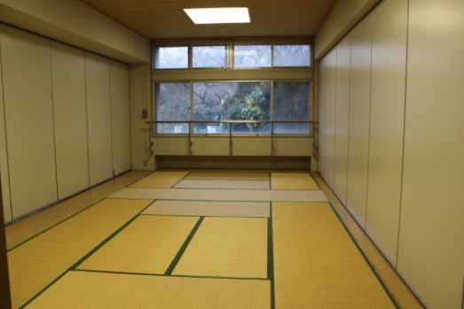
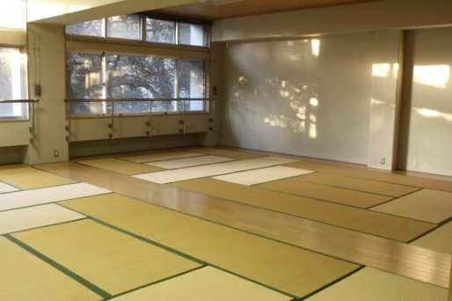
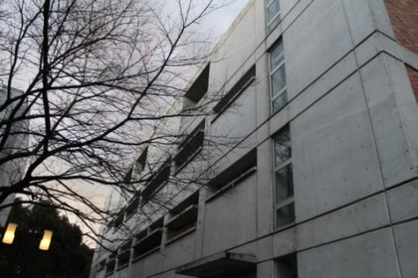

Dormitory Building Small room (Appx.23㎡) Large room (Appx.46㎡)
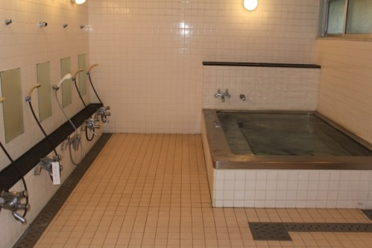
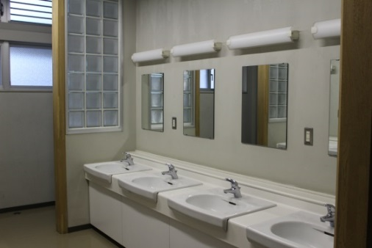
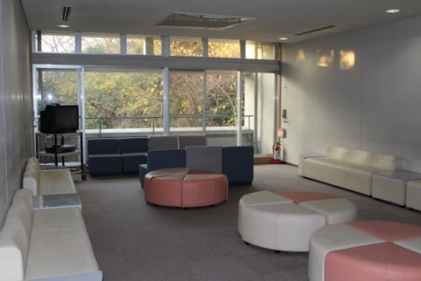

Lobby Bathrooms

