World Tour
Attached document #5
July 10th and July 15th

In this activity, we would like you to introduce your country, including basic information and some tourist spots. The audience for this activity will be CUC students and CUC high school students, and they would enjoy each country’s presentation, as if they were traveling the world. The following is the guideline for the presentations. Presentations will be held by country group. If there is more than one university participating from the same country, we will make it possible for you to communicate with each other by email to create a presentation together before you come to Japan.

Poster Presentation
The poster board 59.4cm (width) x 84.1cm (height) is provided by CUC. Please make sure that your poster fits on the poster board. Poster boards will be freestanding.

All poster presenters are required to be present with their poster during the activity.

The presentation should consist of country name, population, capital city, weather, language, currency and a few tourist spots.

An electronic copy of the final poster must be submitted to the CUC International Center (interex@cuc.ac.jp) by Tuesday, July 9th.

What to bring for this activity
- Traditional costume is recommended.
- Your country’s snack, except alcohol.
- Laptop computer, if you are going to use PowerPoint for your presentation in addition to your poster presentation

If you have any questions about the presentation, please feel free to email and ask us at the CUC International Center, Hiroko Kobayashi (interex@cuc.ac.jp).

Attached document #5
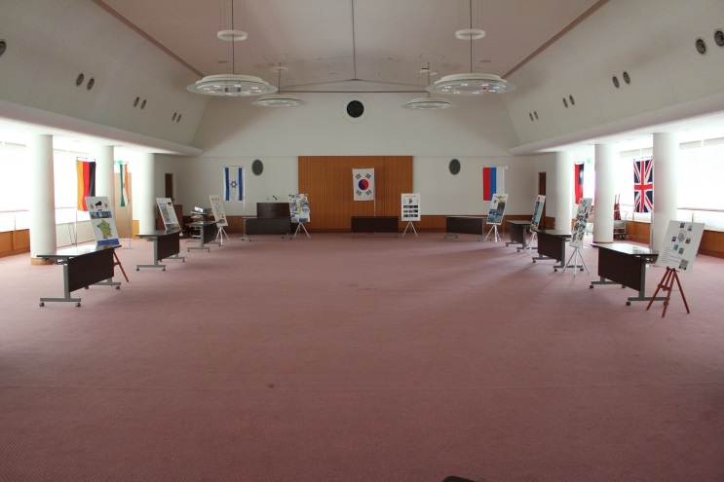
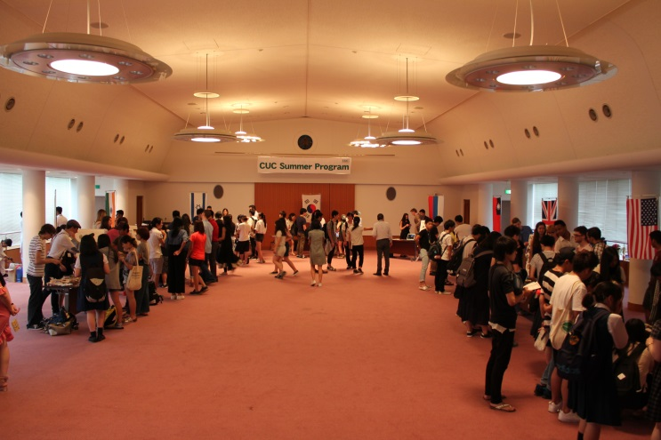
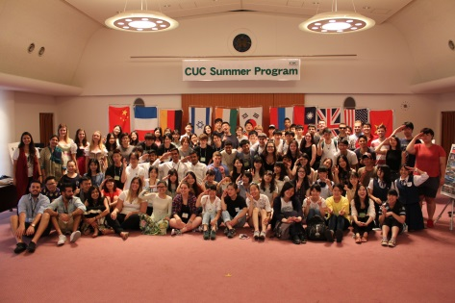
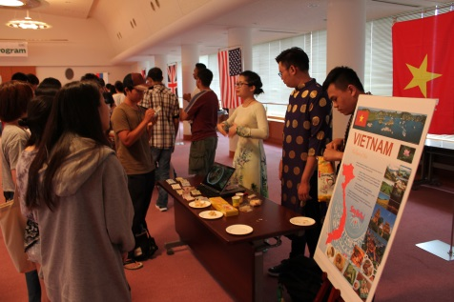
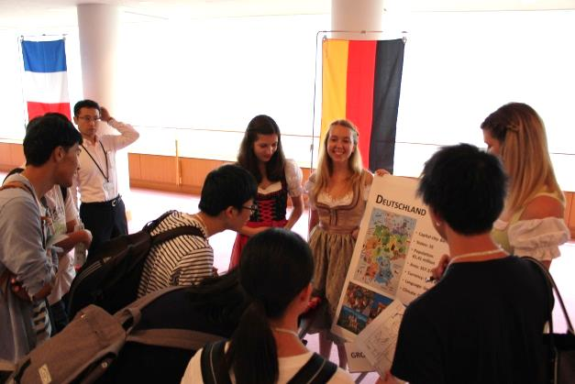
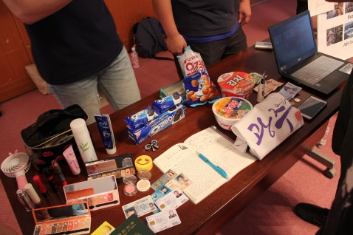
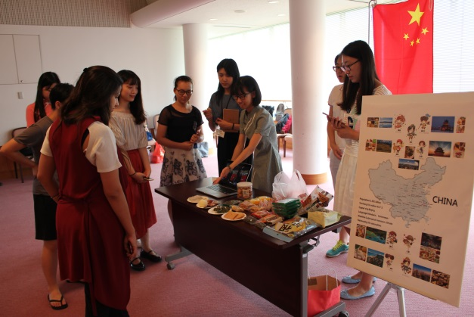
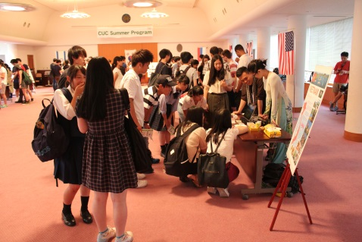
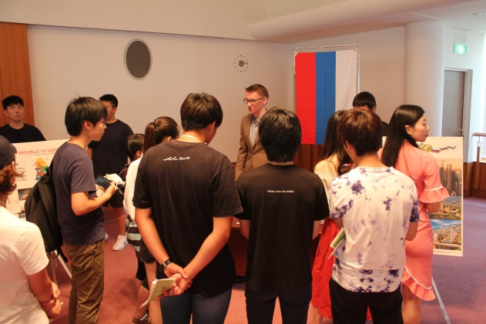
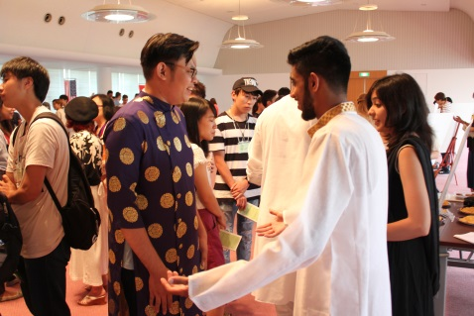
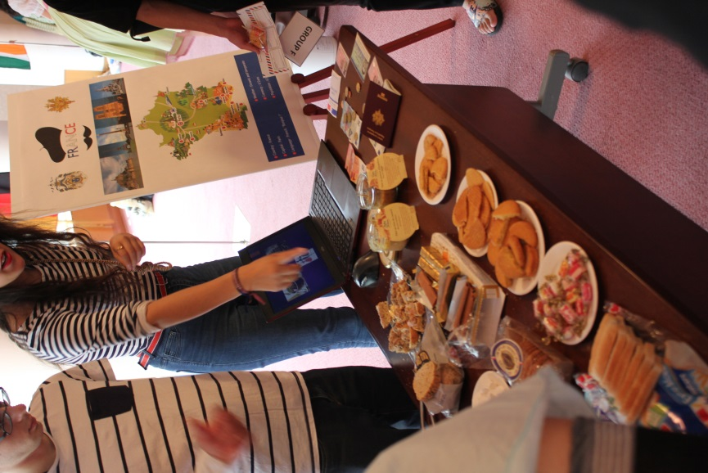
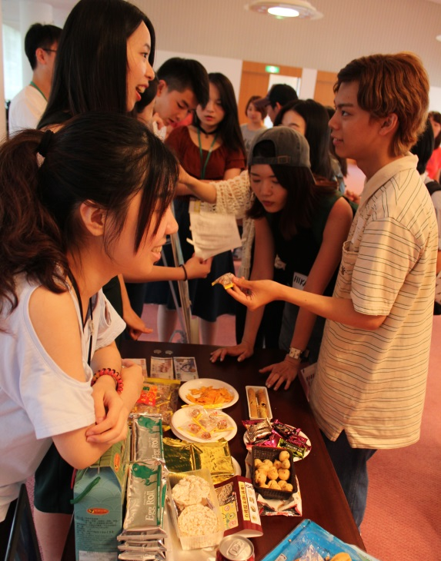
World Tour
CUC Summer Program

